Nepal College of Information Technology
Unit Test
Fall 2013
Program : BE CE Time : 2 hrs
Semester : (V) FM : 70
Subject : Integrated Digital Electronics PM : 35

- Candidates are requested to give their answer as far as practicable in their own words.
- The figure in the margin indicates the full marks
- Attempt ALL question

1. A BJT inverter is shown in the figure below. Assuming β = 70, V_{BE (on)} = 0.65V, V_{BE (sat)} = 0.75V, V_{CE (sat)} = 0.16 V ,Explain and plot its VTC [7]
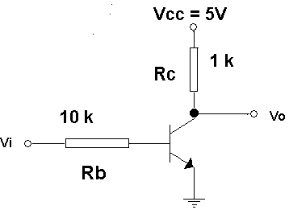
2. Explain why IIL has high packing density. Draw and explain 2-bit IIL decoder. [8]

3. Calculate ∆0 and ∆1 noise margins for medium power commercial RTL gate at 125°C. At 25 °C ,V_{BE (cut in)} = 0.65 V, V_{BE (sat)} = 0.75 V, V_{CE (sat)} = 0.16 V, h_{FE} = 50, σ = 0.85 . [8]
4. a) Explain how the circuit shown below works as a NAND gate. [4]
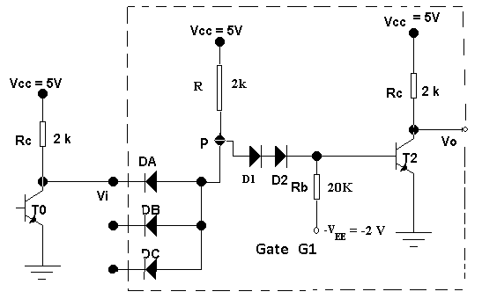
b) What are the functions of the base resistor Rb and the negative supply -V_{EE} , in the output transistor of the discrete circuit DTL gate shown above? [3]
5. Derive an expression for the fan-out (N) for the discrete DTL NAND gate. [7]
6. Draw the high speed TTL circuit and explain the factors that account for the high speed in it. [8]
a) the input diode
b) the darlington circuit and
c) the active pull-down.
OR
Draw the circuit and explain the working of tri-state TTL gate.
7. Draw the circuit and explain the working of NMOS NAND gate. Explain how the effect of stacking is minimized in this circuit. [4+3]
8. Draw and explain the transfer characteristics of CMOS inverter. [8]
OR
Give reasons for the following statements
a) ECL is the fastest logic family. [2]
b) RTL buffer can drive more no. of loads than an ordinary RTL NOR gate. [3]
c) In DTL NAND gate, fan-out is limited when output is at low logic. [3]
9. Write short notes on(Any Two) [10]
a) RTL XOR gate
b) Charge Compensation
c) Physical Layout of IIL

